Inventory Management Tool

CS 157A Team 14

Khoa Phan

Jing Hui Ng

Renad Morrar

1. **Overview:**

Many businesses are having a problem to manage their inventory in an effective way. Our tool is to provide a friendly and useful tool in order to help those businesses be able to manage their inventory more effectively . In detail, the software will help companies to manage the stock of products with various functions such as generating reports, maintaining the balance of the inventory. Moreover, it will provide accurate information about the products without any error. In a general sense, the inventory system will work by allowing the user to manage and keep track of the stock. The most important goal that we are aiming for is providing a customer a better way to manage their business’s inventory more effectively, which will lead to save a lot of money and time for the companies.

**2**. **System Environment:**

**A. A Structure Diagram of the System:**

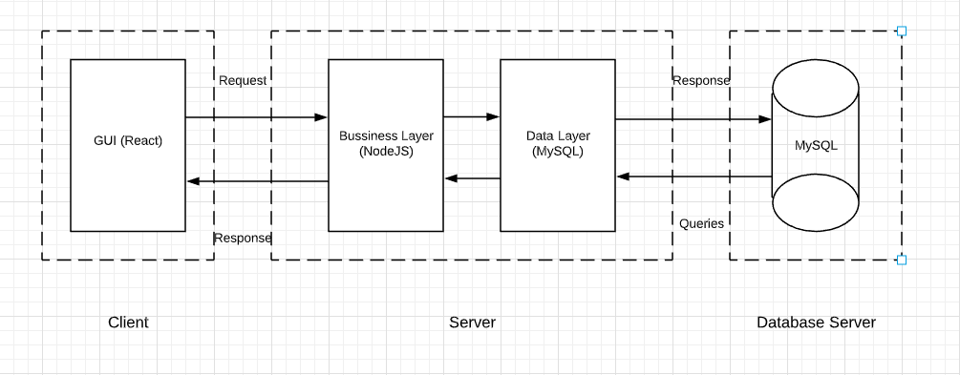

**B. Hardware & Software:**

* Back-end: **Node.js version: 10.16.3** (Javascript runtime environment), **Express.js** v4.16.1(Web application framework for node.js), **npm v6.9.0**
* Front-end: **React v3.0.1** (Javascript library for building UI), **Redux v4.0.4, Material UI v4.4.3**
* Database: **MySQL Workbench v8.0 CE**
* Misc: Any type of web browser (Chrome/Firefox/etc), Linux or Windows environment, and Wifi connect capability
* Visual Studio Code/Atom
* Git & Github
* Slack

**C. Programming/Application languages used:**

* Front-end: CSS, Javascript
* Back-end: Javascript

**4. Non-functional Issues:**

1. **GUI:**

* It should be a Web Application with an user-friendly environment that will be built by using React & Material UI, CSS
* When the user first logged in, the user will be able to navigate directly to the homepage by clicking the special homepage button which will contain a list of items in the inventory.
* On the dashboard, the user will also see a simple search box with a magnifying-glass button that is displayed on the top middle. Also, search box will be provided on every page to ensure that the user is able to find the content they are looking for.
* Auto-suggest mechanism is provided when the user is typing in the search box by predicting what the user trying to look for to speed up the searching process.
* When the user selects on one item, it will show a detailed information of the item selected.
* User is able to edit the quantities of the selected item by changing the number and then simply clicking the update button.
* They should be able to see the pie charts and graphs when the click on the view report button on the web page in order to make stock control and inventory visibly easy, and allow the user to quickly see new trends, and help user to easily visualize the flow of the items.

1. **Security:**

* The system will be protected by a username and password.
* The username for each account will be the user’s corporate-based email to keep unauthorized users from accessing the system.
* The password should have at least 8 characters with on special character.
* In order to log into the system, an existing email account along with the associated password must be provided.
* There will be an inactivity timeout that will prompt the user to login again if the user is inactive for a certain amount of time.

1. **Access Control:**

* Only authorized users whom are employees from the company will be able to access the data and information in the system.
* Different user account will have different levels of permission.
* Access permission or level of permissions may only be modified by the admins account.
* Admin account will have total read and write access.